Excel HR Dashboard Project Documentation
HR Analytics Dashboard Using Excel

1. Objective
The aim of this project is to analyze employee performance, salary distribution, and attrition trends using Excel. The final output is an interactive HR dashboard that provides insights into:
- Employee attrition
- Department-wise salary
- Age group distribution

2. Dataset Overview
- Source: HR Records
- Columns Used:
  - EmployeeID
  - Age
  - Department
  - Salary (Monthly Income)
  - AttritionStatus (Yes/No)

3. Tools Used
- Microsoft Excel (PivotTables, Charts, Slicers)
- Excel 2007 or later

Step 1: Data Preparation
- Imported HR records into Excel.
- Cleaned the data by checking for:
  - Missing values
  - Inconsistent formats
  - Invalid entries (e.g., negative salaries or ages)

Step 2: Attrition Analysis
- Created a PivotTable to analyze attrition based on:
  - Department
  - Gender
- Used a pie chart to visually represent attrition counts (Yes/No) across departments.
Insights:
- Majority of attrition occurred in the Sales department.
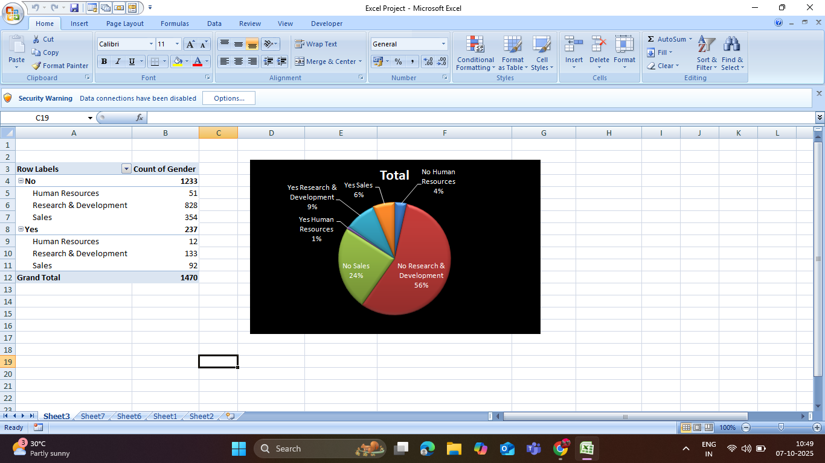
- Research & Development had the lowest attrition rate.

Step 3: Salary Distribution by Department
- Created a PivotTable summarizing Monthly Income by Department.
- Used a clustered bar chart to visualize the total salary distribution.
Insights:
- Sales has the highest total monthly income.
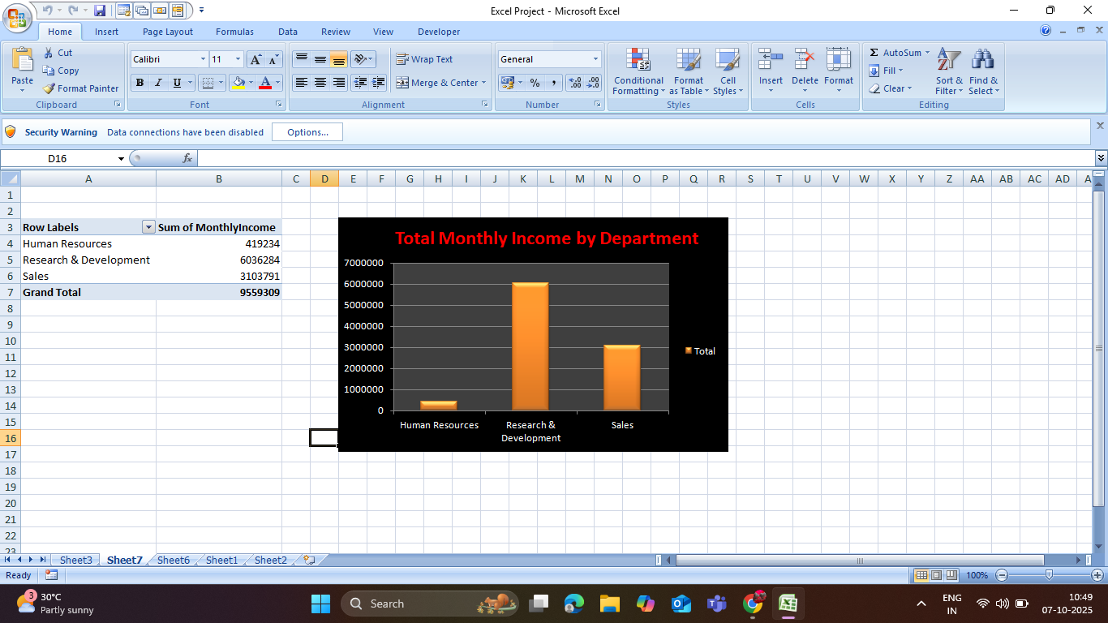
- Human Resources has the lowest salary sum.

Step 4: Age Distribution
- Grouped employees into 5 age ranges:
  - 18–27
  - 28–37
  - 38–47
  - 48–57
  - 58–67
- Created a donut chart to display the employee count by age group.
Insights:
- The highest number of employees falls into the 28–37 age range.
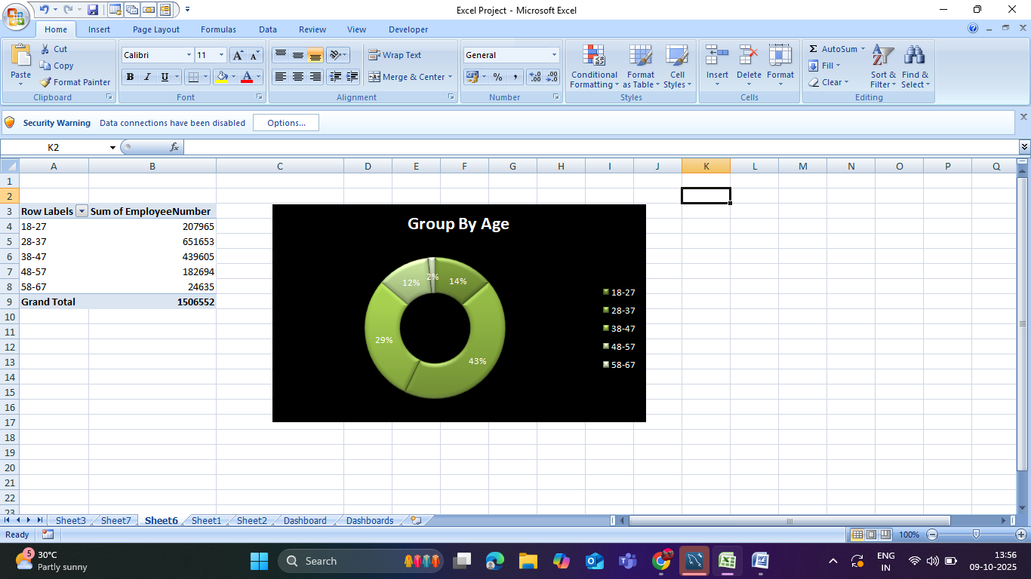
- Older age groups (48–67) are underrepresented.

Step 5: HR Dashboard Creation
- Combined all charts and PivotTables into a single dashboard:
  - Pie chart for attrition analysis
  - Bar chart for department-wise income
  - Donut chart for age group distribution
- Applied slicers for:
  - Department
  - Gender
  - Attrition status (for interactivity)

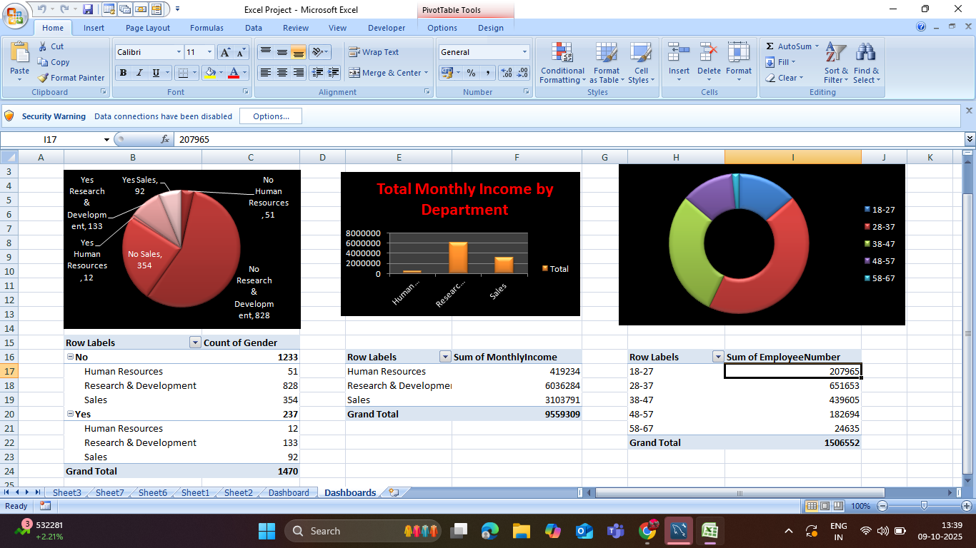

5. Final Dashboard Preview
Included Charts:
- Pie Chart: Attrition Analysis by Department
- Bar Chart: Total Monthly Income by Department
- Donut Chart: Employee Distribution by Age Range

